
Should Tasmania have notional estate laws?



How to use this paper


This paper is written in an easy to read way.
We use pictures to explain some ideas.

Some words are written in blue. We explain what these words mean.

You can ask someone to help you read this paper.
Maybe a friend, family member, support person or advocate.

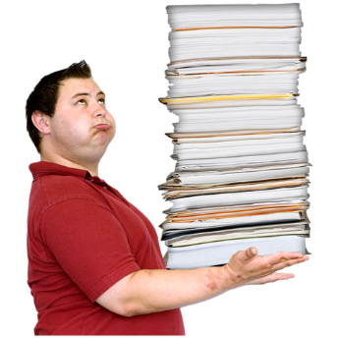
This easy read paper is a short version of a bigger paper.

You can find the bigger paper on our website at
www.utas.edu.au/law-reform/publications/ongoing-law-reform-projects2

What is this about?
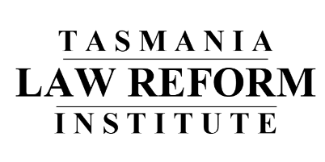
The Tasmania Law Reform Institute is an organisation that looks at Tasmanian laws.


They make sure laws are
- up-to-date
- needed
- fair
- work well


They are asking people if Tasmania needs a new law about
- people’s estates and
- what family members can claim when someone dies
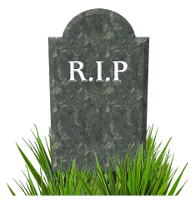


estates are the money and things owned by someone when they die

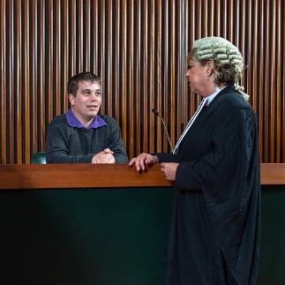
claim is when you ask the Supreme Court for more from the estate.

How can I have my say?

There are questions so you can have your say.
You can answer as many questions as you like.

Send your answers to

Tasmania Law Reform Institute
Private Bag 89
Hobart, TAS 7001


If you have any questions Kate can help.
Mrs Kate Hanslow
(03) 622 621 92

kate.hanslow@utas.edu.au


We must have your answers by
24 May 2019

What the law says now

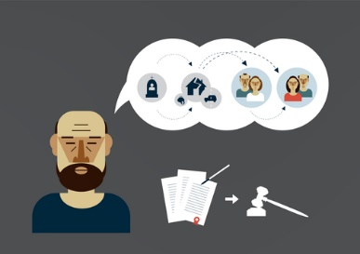
In Australia you can make a special document called a Will.
A Will is how you tell people what should happen to the things you own when you die.

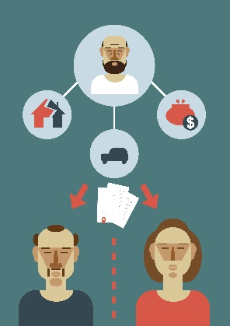

The law says people can leave the things they own to anyone they choose.

But the Testator’s Family Maintenance Act is a law that says some family members can make a claim to the Supreme Court if
- they weren’t left anything in the Will
- they think they should get more.

Claim is when someone asks the Supreme Court to decide what should happen.


People who can make a claim are the person’s
- wife or husband
- children
- parents, if there are no children or husband or wife.

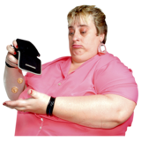
They need to prove that they have not received enough in the Will and
that the deceased’s Will shouldn’t be followed.
Deceased means the person who has died.


When the Court is making their decision, they think about
- the size of the estate
estate is the money and things the person owned


- the relationship between the person making the claim and the deceased

- what the person making the claim needs

- other family members and their needs

- why the deceased made the decisions in their Will.

If the Court agrees that the person should get more it can say how much they will get from the estate.

Tasmanian Law says the Supreme Court can only use what is in the estate.

They cannot use other assets.
assets are money and things.

Sometimes people organise their money and assets in ways that mean it isn’t part of the estate.


They might do things like

- give someone their money or property

- have their superannuation paid to someone

- make their house go straight to their husband or wife.

This may be to

- help someone in their family

- thank someone for helping them

- pay less tax

- keep assets safe.

But it might be to stop their family from making a claim.


Here is a story to help explain
Everyone thought Harry was wealthy.
His daughter Sue was shocked that when he died his estate was $1000.
Harry gave shares worth $500,000 to a friend before he died.
On Harry’s superannuation form he said his wife must get the $400,000 payment.

The law as it is now means these are not part of Harry’s estate,
so Sue cannot make a claim.

Lucy and her partner Gary are 60.
Both have their own children.
Lucy owns a house in Smithton.
It is just in her name because she received it from her husband’s estate.

Lucy wants to make a Will that leaves the house to Gary.
Lucy finds out that her children can challenge a gift of the house to Gary in her Will.

She also finds out that, if the property documents said they were joint tenants, Gary can automatically get it.
It will not be part of Lucy’s estate so cannot be challenged by her children.

She decides to transfer the house so that she and Gary own it as joint tenants.

On her death, Lucy’s children cannot claim any of the house, as Gary automatically gets the property as the last owner who is alive.

Jenny takes out a life insurance policy to make sure there will be enough money for her daughter, Tamika, to finish school if Jenny dies.

Jenny does not want the money from the policy to be paid to anyone else. She wants it just for Tamika’s benefit.

Jenny decides to put Tamika’s name on the insurance form.
This means the life insurance company must pay the money to Tamika if Jenny dies.

The law as it is now means no one can make a claim to get any of the money.

Notional Estate Laws
NSW changed their Law so assets that are not part of the estate can be used when a family member makes a claim.

This is called a notional estate.

Notional estate can include

- gifts made to someone in the three years before death


- property the deceased owned jointly with others

- life insurance

- superannuation


The Court can only use notional estate if there is not enough money in the estate.

It can only give notional estate to family who the Court thinks should have more.

The court needs to think about what people thought would happen and what is fair.

Mr Smith has three children. His only asset is a farm at Deloraine.
His daughter Sandra lives with Mr Smith and helps with the farm and jobs around the house. Mr Smith does not speak to his two sons, who live in Sydney.
Mr Smith wants Sandra to take over the farm when he dies. He does not want the farm to be sold and is very worried this may happen if his sons claim a share of his estate after he dies.
Mr Smith decides to give the farm to Sandra during his life. The law as it is now means when Mr Smith dies, the farm is not part of his estate. And his sons have no claim to it.
If we have notional estates the Court could use the farm to give more to his sons even though Sandra owns it.

Should we change our Law?

Notional estate law

- stops people from arranging things in ways that make their estate small so their family cannot claim


- helps the court make sure that family members who make a claim can get what is right.

Some people do not support notional estate laws because they change the decisions and wishes of the deceased.
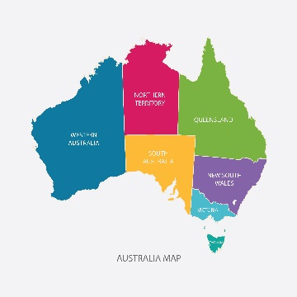


South Australia and Victoria did not change their Law because they disagreed with the idea.

Questions for you to think about

- Have you seen any times when people made their estate small so there was less for family members to claim?

Can you say what they did?

Questions for you to think about

Questions for you to think about

2. While people are alive, should they be allowed to organise their money and assets so not everything will be in the estate?

What makes you think this?

Questions for you to think about

3. What do you think about Tasmania having a law about notional estates?
- it’s a very good idea
- it’s a good idea
- the idea is ok
- I don’t know
- it’s not a good idea
- it’s a bad idea
- it’s a really bad idea

Why do you think this?

Questions for you to think about



4. Can you think of any problems or issues with having notional estate laws in Tasmania?

Questions for you to think about

4. Can you think of any problems or issues with having notional estates in Tasmania?

Questions for you to think about

5. If Tasmania changes the Law so there are notional estates, what should it say about
- the kinds of property that can be used?

- the importance of what the deceased person was trying to achieve?

- the amount of time before the deceased person died that is looked at?

- the situations when notional estate orders can be made?

- other things?

Questions for you to think about

6. Is there anything else you would like to tell us about notional estate laws?



This easy read document was created by Speak Out
Association of Tasmania. We use photosymbols®
stock and custom images.
For information on easy read email:
burnie@speakoutadvocacy.org

