


Legal Recognition
of Sex and Gender



How to use this paper

This paper is written in an easy to read way.
We use pictures to explain some ideas.

Some words are written in blue. We explain what these words mean.

You can ask someone to help you read this paper.
Maybe a friend, family member, support person or advocate.


This easy read paper is a short version of a bigger paper.

You can find the bigger paper on our website at
https://www.utas.edu.au/law-reform/publications/ongoing-law-reform-projects2


Send your answers to:
Tasmania Law Reform Institute
Private Bag 89

Hobart, TAS 7001

For more information ring (03) 6226 2069
What is in this paper

How to use this paper 2
What is this about? 4
Part 1 Before the law changed 9
Questions for you to think about 18
Part 3 Consent to medical treatment for intersex children 19
Questions for you to think about 21
How could the law be changed? 22
Questions for you to think about 26

What is this about?
TLRI log
The Tasmania Law Reform Institute is an organisation that looks at Tasmanian laws.
We are called TLRI for short.


We make sure laws are
- up-to-date
- needed
- fair
- work well

We are looking at what Tasmanian law says about


- How a person’s gender is shown on official documents, like birth certificates.




Gender is how male or female you feel you are.


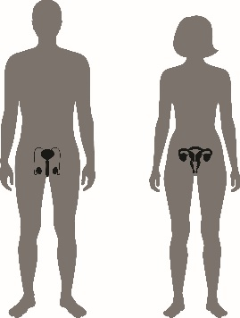
- Consent to medical treatment to change sex characteristics.

Consent means saying yes and agreeing to something happening.


Sex characteristics are the physical body parts you have, like
- a penis

- a vagina
- reproductive system
- if you have breasts or can grow a beard.

Gender and sex are different things.

What is sex?
Many people think when someone is born they have a penis or vagina and are male or female.

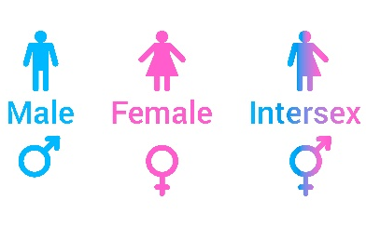
But some people have both male and female parts in their body.
These people are often called intersex.
Intersex means having both male and female body parts.



What is gender?
Gender is how male or female you feel you are.
Many people feel their gender is the same as their sex
but for some people it is not.





Being transgender is when you know there is a difference between your physical body parts and how you feel inside.


If you have male sex characteristics, you can feel you are female, and you may
- live like a female
- dress as female
- prefer being referred to as, she or her.


If you have female sex characteristics, you can feel you are male and may
- live like a male
- dress as male
- prefer being referred to as, he or him.


A person can have an operation to change their body to be more like how they feel inside.



Some people don’t feel like they are male or female.
This is called non-binary.
Non-binary means feeling like a mix of genders
or feeling no gender at all.

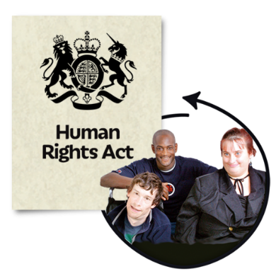

Everyone has the right to equality in the law
and to be treated with dignity and respect.

People cannot be treated differently because of their sex or gender.



In April 2019 new laws changed the way Tasmanians register information about
- their sex

- their gender.

We want to find out what people think about

- the changes made to the law in April 2019

- other ideas to make the law fit better with Human Rights and other laws.

There are 3 parts to this paper to help you understand the issues:
- Before the law changed

- Legal issues arising from the changes

- Consent to medical treatment for intersex children
Intersex means having both male and female body parts.



There are questions, so you can have your say.

Part 1 Before the law changed


- A person had 60 days to tell the Registrar of Births, Deaths and Marriages if the baby was male or female.

Registrar is the person who collects important information about births, deaths and marriages.

- A person could apply for a birth certificate for the baby.
The birth certificate said if the baby was male or female.

- If someone wanted to apply to change their sex, they had to have an operation to become that sex.


If they got a new birth certificate, it would say their new sex and their former sex.

Here is an example to help explain the old law:

A person with female sex characteristics wanted to be registered as a man because that is how they felt inside.
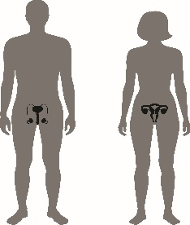
To register they needed to have an operation to
- remove some of their female sex characteristics
- and look like a male.

These operations are expensive and not fully covered by Medicare and public health care.
They can be dangerous and hard to get.
If they got a new birth certificate it would say their sex was male, but they used to be female.

What the new law says


- All babies must still be registered as male or female.
The new law says when it is hard to tell if a baby is male or female, a parent can have 120 days to tell the Registrar.


This gives parents of intersex children more time. They can get advice from their doctor about the sex of their baby.

- A person can apply for a birth certificate
but it won’t say the baby’s sex unless they ask for it.

- A person over 16 can apply to the Registrar to change their gender without having an operation.

They need to sign a legal document to say

- what gender they feel they are

- and they will live as that gender.


Some people may decide to have an operation, but they don’t have to do this.

- For a child under 16, their parents can register a change of gender for them.

If their parents don’t agree, one parent can apply to the court to decide what to do.



The Registrar makes sure the child understands and wants to change their gender.

The Registrar can ask the child to see a counsellor to make sure they understand what it means to change their gender.

When a person changes their gender
The Registrar puts the person’s new gender in the Register of Births, Deaths and Marriages.

It replaces any information about the sex or gender of the person.

The person can ask for a new birth certificate
- with the new gender, or

- without any information about sex or gender.

Here are some stories to help explain

At birth, Jay’s sex was registered as female.
She lives as a female and
has not applied to register her gender.
For the purposes of any laws about sex or gender, Jay is female.

Ty is an intersex person.
At birth, Ty was registered as female.
As a teenager Ty had surgery and registered a change of sex to male.
With the new laws, Ty decided to have no sex or gender registered.
For the purposes of any laws about sex or gender, Ty is not female or male. This is sometimes called non-binary.
Non-binary means feeling like a mix of genders
or feeling no gender at all.

At birth, Kai was registered as female.
As a teenager, Kai had medical treatment to block puberty but did not have an operation.
Puberty is when the body starts to change from child to adult.
Kai successfully applied to register as non-binary or feeling a mix of genders.
In the next few years, Kai felt more male and applied to change his gender to male.
For the purposes of any laws about sex or gender, Kai is male.


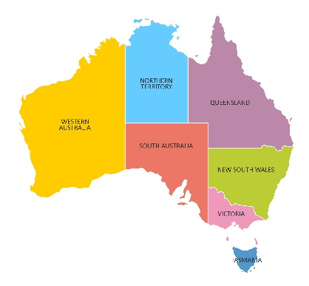
The new law makes Tasmania the only place in Australia where you don’t have to change your body or have medical treatment to change your gender.
Victoria is thinking about making their laws like the new Tasmanian laws.

Part 2 Legal issues from the changes


Some people worry that the new laws will make things harder, like:
- getting a passport

- the government having information to plan

- police investigations

- joining a men-only or women-only sports club.



Tasmanians will still be able to get passports:
The Australian Passports Office already uses gender for passports.

People can say they are
- male (M)
- female (F)
- intersex or unspecified (X)

The Passport Office must work out what information Tasmanians need to show if their birth certificate doesn’t have their gender.

A person can change the sex on their passport without having an operation.

Collecting information will not be harder.
The government will still know what the Tasmanian population is like because all babies are registered as male or female.

The new law gives parents more time if they need it.


Police investigations will not be harder.
Police and other government agencies can still access information about a person even if they change their gender.

Police officers can still search intersex and gender diverse people.

Gender diverse is the term used to describe people who are transgender and non-binary.

If an officer of the same gender is not available, the person will be asked if they would like a male or female officer to do the search.
Many clubs, organisations and accommodation are set up for men or women only.

These places will need policies so they can
- include people who are intersex and gender-diverse

- and make sure all members are respected and not discriminated against.

Policies are rules and guidelines that help people know what to do.

Questions for you to think about

What do you think about the new laws?

Should there be any changes to the new laws?

Do you know any clubs or organisations that have policies about gender-diverse people?

How do the policies work?

Part 3 Consent to medical treatment for intersex children
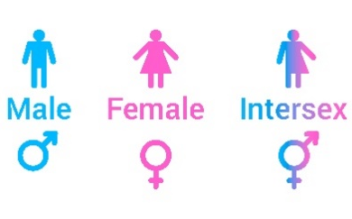
Some people are born with parts that don’t look fully male or female.
+
=

These people are often called intersex.


Sometimes parents of intersex children ask a doctor for medical treatment or surgery for their child.
They may want their child to be what they think is usual for male or female children.

This can mean operations to change the child’s penis or vagina.

Parents and doctors often think this is best for the child.



But sometimes intersex people wish the operations had not been done because:
- they may have health problems

- they may not be able to have children

- their body doesn’t fit the way they feel.
The law as it is now, says that medical treatment or operations can be done with

- the consent of the parents



- or the consent of the court.

A doctor does not need the child to give consent.


Many intersex people think medical treatment or operations to change body parts should not be done until someone is older and can:

- understand what the treatment means

- decide it they want to give consent.

Questions for you to think about

Should parents be allowed to ask a doctor to do surgery on an intersex child?

Should doctors be allowed to do surgery on an intersex child without the child’s consent?

Why do you think that?

Are there times when it is ok to do surgery without the consent of the intersex child?

What are these times?

What should parents and doctors have to think about before they consent to surgery on an intersex child?

How could the law be changed?

The TLRI is looking at how to change the law to protect the rights of intersex children.




Here are some ideas the TLRI are thinking about:
- Make it a crime to operate on a child without the child’s consent.
This means doctors who operate without the child agreeing could be charged by the police.

A doctor would not be charged if they could show that the operation was needed to protect the child.


- Set up a special Tribunal or group of people to make decisions about operations on intersex children.

The Tribunal would have doctors, psychologists, social workers and intersex people.


They could talk to the child and find out
- if there is a real medical need for the operation

- if it can wait until the child is old enough to make their own decision.

Parents who want a doctor to operate on their child would need to get approval from the Tribunal.

- Make a new law with rules about operating on
intersex children.

The law could say doctors can only operate if:

        - the parents and child have talked to a counsellor and understand everything involved in the operation; and

        - the child understands what the operation
involves and gives consent.

Or


        - if the child is too young to understand,
the child’s parents have given consent and the doctor believes the operation is


urgent, and

in the best interests of the child.

If a doctor operated without following these rules, they could be fined or stopped from doing any more operations.

- Make a Code of Practice for doctors
with rules about when they can operate on intersex children.

If a doctor did not follow the rules in the Code, an intersex child could complain to the Health Complaints Commission.


        - Give money to intersex organisations so they can
- publish information about intersex


- provide training for doctors and parents about the effect of operations on intersex children


- provide counselling and support to parents and intersex children to help them to make decisions about what to do.

Questions for you to think about
Do you think Tasmania needs rules about operating on intersex children?

If so, what changes should be made to protect the rights of intersex children?

When do you think that an intersex child is able to give their own consent?

Should there be an age limit (for example, if they are older than 14)?

Or

Should it depend on whether the child understands what the operation involves?

