
Legal Recognition of Sex and Gender
Written Consent

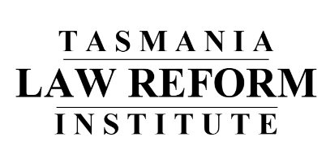





The Tasmania Law Reform Institute (or ‘Institute’) is an organisation that looks at Tasmanian laws.

We make sure laws are

- up-to-date
- needed
- fair
- work well.

We are looking at what Tasmanian law says about
• How a person’s gender is shown on official documents, like birth certificates

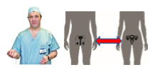





www.utas











• Consent to medical treatment to change sex characteristics.

Gender and sex characteristics are different things. The paper explains what these things mean.

There are questions in the paper so you can have your say.

We might share what you tell us:

- on our website;

- in a report.
If you don’t want us to share what you say, please tell us.

We will respect your privacy.








Telling us what you think is up to you.

You can change your mind up until we finish writing our report.

You can tell us you have changed your mind

(03) 6226 2069
Law.Reform@utas.edu.au








We can’t take your comments out after our report goes to be printed

If you not happy with how we have done our study, you can tell the Tasmanian Social Sciences Human Research Ethics Committee

(03) 6226 6254
human.ethics@utas.edu.au.

Tell them ethics reference number [H0016752].

Please tick (√) how you want us to use what you tell us:

- The TLRI can share what I say and tell people that I shared my ideas

- The TLRI can share what I say but not tell anyone my name

- The TLRI cannot share what I say

………………………………………… …………/……………/…………………
Signed Date

Name: …………………………………………

Phone Number: …………………………………………

Email: …………………………………………

