
Suggestions to Change the
Guardianship and Administration Law

What is this paper about?

This booklet explains some changes the Tasmania Law Reform Institute want to make to the law.

How to use this paper



This paper is written in an easy to read way.
We use pictures to explain some ideas.


Some words are written in blue. We explain what these words mean.

You can ask someone to help you read this paper.

Maybe a friend, family member, support person or advocate.



This easy read paper is a short version of a bigger paper.



You can find our bigger paper on our website at http://www.utas.edu.au/law-reform/publications

Suggestions to change
the Guardian and Administration Law


The Tasmania Law Reform Institute make sure laws are fair, up-to-date and work well for the community.


They have had a close look at the Guardianship and Administration Act 1995 (Tas)

They looked at:

- what is good about the law

- what needs to be changed.


They have made some suggestions about what should change to make things better.

This paper is about changes that should be made to the Guardianship and Administration Act that may affect you.

Guiding Principles of the Act

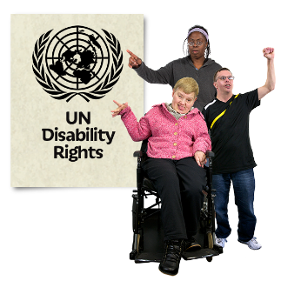
The new law should include ideas from the United Nations Convention on the Rights of Persons with Disabilities (UNCRDP).

We call this the Convention for short.
These are rules that countries should follow.

The changes to the Guardianship and
Administration Act will help get closer to what the Convention says:


People with disability are to be respected for who they are

They are free to make their own choices

Everyone should have equal opportunities


People with disability should be safe and free from abuse, violence and neglect.

Support to make decisions


The new law should say

      - if you are an adult you have the right to help to make decisions if you need it



      - you can choose who you want to support you with personal decisions



      - you can put the name of the person who supports you to make personal decisions in writing so people know

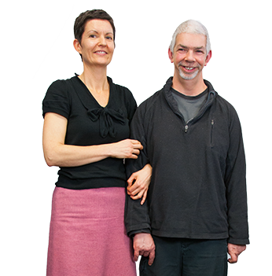
Help from people you know and trust that is given freely is called informal support.

People who support you to make a decision are called supporters.



Support to make a decision is a good thing because you are still making decisions about your life.

Making decisions


The law should say you can still make a decision, even if:

- someone else thinks your decision is bad



- you can only remember information for a little while


    - sometimes you can make a decision and sometimes you cannot


- you are not good at reading and writing.

Decision-making Ability

Decision-making ability is being able to make a decision on your own or



with help from people you know and trust.


In the law, decision-making ability means

- adults should be treated as being able to make a decision

- everyone must assume you can make decisions

Assume means thinking it is true.


When someone is working out your decision-making abilities they need to do it

at a time and place that is best for you.

Representative Decision-making

If someone thinks you cannot make a decision for yourself they need to prove to the Guardianship and Administration Board that:


- you do not understand the information you need to make a decision

- you do not remember or use the important parts of the information

- you cannot let people know your decision.

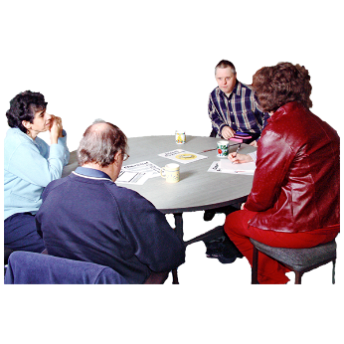
The Board must make decisions that are right for each person and only appoint a representative to make decisions that are needed and if there is no other way.

Representatives are guardians or administrators who make decisions about a person’s life.

Having someone else make your decisions should only happen if there is no other way.

The new law should say that before the Board appoints a representative they must find out

- what informal supports have been offered to you

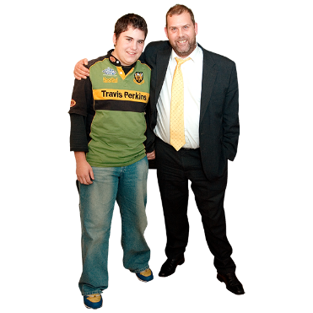

- if there is another way to help you with decisions

- what your carer or family thinks.


If you can make a decision with support,
the Board can pick someone to be your supporter for personal decisions

supporters can be used instead of a representative.

But if you do have a representative, they should


- work with you

- let you be part of making decisions

- not make decisions you can make yourself

- tell the Board if things change and a person does not need them anymore.

Decision-Making Process

The new law should say the steps representatives and the Board take before making a decision for you.


This is called the decision-making process.

- Work out if a decision is needed

- Could you make the decision in the future?

Can it be put off till then?



- If a decision needs to be made

What do you think, want and prefer?

- If your wishes cannot be worked out

Information should be gotten from people who know you well

- A decision needs to be what you want and prefer

unless what you want is against the law or harms someone.

- If your wishes cannot be worked out, or can’t be followed decision-makers must make a decision that
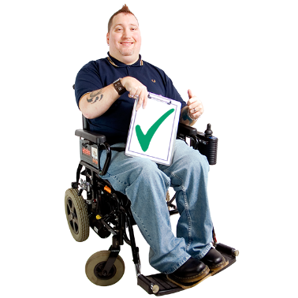
- is good for your personal wellbeing

- is good for your social wellbeing

- protects your human rights.

Safeguards for Representative Decision-making

Safeguards are ways to protect your rights and safety.

The new law should have different ways of safeguarding people.

Representatives should only make decisions
when they are needed and

for as long as they are needed.

They should be appointed for as short a time as possible.


A person can ask the Board to think again about a decision.

This is called an internal review.

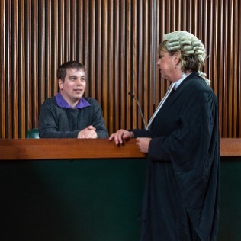
If you still disagree with the decision and appeal to the Supreme Court it should be easier and not cost money.

Appeal means going to court and asking if they agree with the decision the Board made.

The Board can have ways of fixing problems without going to court.

They should be able to refer people for mediation


Mediation is when people sit down together to try to fix the problem before the Board decides.

The Board should have mediation services you can use.

The Public Guardian should have greater powers:

to investigate complaints about representatives


to decide what they look into

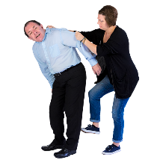
to investigate when a person with disability may be at risk of abuse, neglect or being taken advantage of

to get information that they need.

Making decisions in Advance

The right to have an Advance Care Directive should be part of the new law.

Advance Care Directives allow you to say
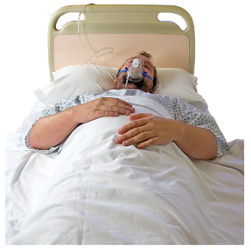
      - what kind of medical treatment you want in the future if you are unable to speak for yourself

      - what care you want at the end of your life.

Anyone who can make decisions can make an advance care directive.


An Advance Care Directive should be ok and respected even if it is not written in a formal way.

The Act should say that part of the job of guardians and doctors is to find out if a person has an Advance Care Directive.

An Advance Care Directive must not have things in it that
- are against the law

- make a doctor do something that breaks the law or is against their job.



Guardians and doctors should follow a person’s Advance Care Directive as best they can.

Helping people understand the Act

People need to understand any changes to the Guardianship and Administration Act.
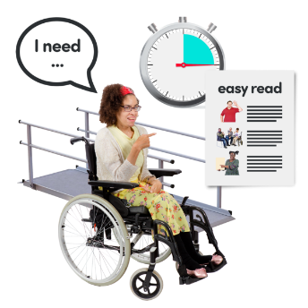
There should be:
money for information and resources so people can learn

information that is accessible.

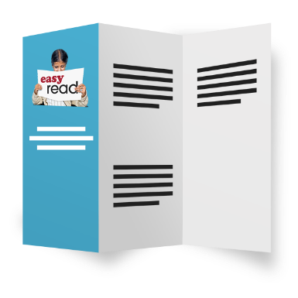
We should make the Act easier to read and understand
- use plain English
- explain hard words and terms
- keep it short
- make it easier to follow.


There should be an education program for the community about having informal support to make decisions.

Everyone needs to understand that informal support to make decisions about your own life is a good thing.

